Outdoor Wireless LED Par Light
12X18W 6in1 LED

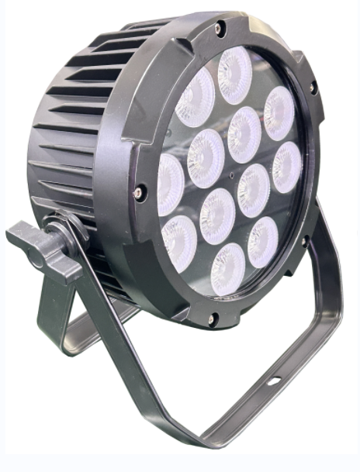

User manual
Please read the instructions carefully before use

Statement
The product has well capability and intact packing when leave factory. All of the user should comply with warning item and manual, any misuse cause of the damages are not included in our guarantee, and also can not be responsible for any malfunction & problem owing to ignore the manual.

1. Safety Instructions
* Please keep this User Guide for future consultation. If you sell the unit to another user, be sure that they also receive this instruction booklet.
* Unpack and check carefully there is no transportation damage before using the unit.
* Before operating, ensure that the voltage and frequency of power supply match
the power requirements of the unit.
* It’s important to ground the yellow/green conductor to earth in order to avoid electric shock.
* The unit must be installed in a location with adequate ventilation, at least 50cm from adjacent surfaces. Be sure that no ventilation slots are blocked.
Disconnect main power before replacement or servicing.
* Make sure there are no flammable materials close to the unit while operating as it is fire hazard.
* Use safety cable when fixes this unit. DO NOT handle the unit by taking its head only, but always by taking its base.
* Maximum ambient temperature is Ta: 40℃. DO NOT operate it where the temperature is higher than this Unit surface temperature may reach up to 85℃. DO NOT touch the housing bare-hand during its operation. Turn off the power and allow about 15 minutes for the unit to cool down before replacing or serving.
* In the event of serious operating problem, stop using the unit immediately.Never try to repair the unit by yourself. Repairs carried out by unskilled people can lead to damage or malfunction. Please contact the nearest authorized technical assistance center. Always use the same type spare parts.
* DO NOT touch any wire during operation as high voltage might be causing electric shock.

Warning:
* Please set one light only as master when used Master-slave model in the same channel.
* DO NOT set any light as master when used DMX hold model.
* To prevent or reduce the risk of electrical shock or fire, do not expose the unit to rain or
moisture.
* DO NOT open the unit within five minutes after switching off.
* The housing, the lenses, or the ultraviolet filter must be replaced if they are visibly damaged.

Caution:
There are no user serviceable parts inside the unit. DO NOT open the housing or attempt any repairs yourself. In the unlikely event your unit may require service, please contact your nearest dealer.

Installation:
The unit should be mounted via its screw holes on the bracket. Always ensure that the unit is firmly fixed to avoid vibration and slipping while operating. And make sure that the structure to which you are attaching the unit is secure and is able to support a weight of 10 times of the unit’s weight. Also always use a safety cable that can hold 12 times of the weight of the unit when installing the fixture.
The equipment must be fixed by professionals. And it must be fixed at a place where is out of the touch of people.

2. Technical Specifications
Light Sources: 12*18W 6in1 RGBWA+UV LED
Beam Angle: 25°
Power Voltage: AC 100-240V, 50/60Hz
Net Weight: 5Kgs

Control
DMX Channel: 6/8/10 Channel
Control Modes: DMX512, wireless DMX and Wifi control

Construction
Display: LED Display
Data In/Out socket: 3-pin XLR sockets
Power Socket: Powercon in/out
Protection Rating: IP65
Features
* Auto power
* IP65 Powercon in/Out ,IP65 DMX in/out
* Option for change LED Power (Eco, Medium, High power)
* Battery Charging Information and Wireless Channel change in Display
* Emergency Mode (enable / disable)
* DMX hold （on/off）in display
* Timer on/off

3. How To Control The Unit
The DMX512 is widely used in intelligent lighting control,with a DMX 512 controller.connect several lights together,dmx in and dmx out,
3 pin XLR connectors: Pin 1: GND, Pin 2: Negative signal (-), Pin 3: Positive signal (+)
Display:

MENU To select the programming functions
DOWN To go backward in the selected functions
UP To go forward in the selected functions
ENTER To confirm the selected functions

Set DMX Address Code
1 Press "Menu" to "Set DMX Address",and press"ENTER" keys to enter into
2 Show "Set DMX Address DMX Address:001",Press the "UP and DOWN"
keys to amended
- Press "ENTER"keys to save and Exit,Press the"MENU"Keys does not save and Exit.
- Turn on operation: when in charging or turn off, press "MENU" for more than 4s,then screen will display clients' logo and model of products,
- there are "MENU","UP"."DOWN" for your selection to choose the function,press" ENTER" to confirmed and enter the next menu,press "MENU" could back to the last menu.
- When turn on , press" MENU" for more than 4s,the screen will display " Power Off",and will close LED output by then.
- If charger connect with electricity,the screen will display charging icon and percentage of battery power. Or will be turn off directly,and the battery
powered will be totally cut off.
- When using Master-Slave model,apart from the first one as Master without setting,the others need to set as Slave.
- When using DMX512 controller,all the lights need to set as DMX model.

MENU
Menu |  | Function
A001 | A001—A512） | DMX Address 001-512
Chnd | 6CH | 6 channels mode
Chnd | 8CH | 8 channels mode
Chnd | 10CH | 10 channels mode
FAIL | BLND | Data is not maintained (black field)
FAIL | HOLd | Data retention
CL01 | CL01—CL32 | 32 static color mixing modes, color selection by up and down keys  Strobe mode St00-St16 after confirmation, adjust by up and down keys
AUT0 | AUT0 | Auto mode 0, speed adjustable SP01-SP16
AUT0 | AUT1 | Auto mode 1, speed adjustable SP01-SP16
AUT0 | AUT2 | Auto mode 2, speed adjustable SP01-SP16
AUT0 | AUT3 | Auto mode 3, speed adjustable SP01-SP16
AUT0 | AUT4 | Auto mode 4, speed adjustable SP01-SP16
SOU0 | SOU0 | Sound mode 0
SOU0 | SOU1 | Sound mode 1
SOU0 | SOU2 | Sound mode 2
SOU0 | SOU3 | Sound mode 3
WIFI | LED-XXX | WIFI
NANU | R000-255 | R manual dimming
NANU | G000-255 | G manual dimming
NANU | B000-255 | B manual dimming
NANU | U000-255 | W manual dimming
NANU | Y000-255 | A manual dimming
NANU | P000-255 | UV manual dimming
NANU | S000-255 | Strobe manual dimming
NANU | d000-255 | Brightness manual dimming
TEST |  | Color self-check
LED | ON | Display ON
 | OFF | Display OFF
IRCL | ON | IR remote control ON
IRCL | OFF | IR remote control OFF
2.4G | ON | Wireless 2.4G ON (press the ENTER button for 3 seconds to enter the frequency modulation: 1-7)
2.4G | OFF | Wireless 2.4G OFF
POUR | ON | One key switch machine, ON | Pressed MENU button for 3 seconds to turn ON/OFF
POUR | OFF | One key switch machine, OFF
VER | V1.0 | Software version

DMX channel´s functions and values (6/10/10 DMX channels):
CH | 6CH | 8CH | 10CH
CH1 | 0-255 Red | 0-255 Dimmer | 0-255 Dimmer
CH2 | 0-255 Green | 0-10 OFF  11-255 Strobe (Slow-fast) | 0-255 Red
CH3 | 0-255 Blue | 0-255 Red | 0-255 Green
CH4 | 0-255 White | 0-255 Green | 0-255 Blue
CH5 | 0-255 Amber | 0-255 Blue | 0-255 White
CH6 | 0-255 UV | 0-255 White | 0-255 Amber
CH7 |  | 0-255 Amber | 0-255 UV
CH8 |  | 0-255 UV | 0-9 OFF，  10-255 Strobe (Slow-fast)
CH9 |  |  | 0-9 OFF  10-50 Static Colors(Ch10  choose color)  51-100 Colors Jump  101-150 Colors Gradual  151-200 Colors Pulse  201-220 Sound mode 1  221-240 Sound mode 2  241-255 Sound mode 3
CH10 |  |  | 0-255 Speed(slow to fast)

4.Remind
*It need to charge a times for each two months,and 50% battery power at least, if for a long time without using.
When turned off the lights and charging, the battery information in display shows 100%, please continue charging more than 1 hours, then get maximum discharge time.

